**LPG Leakage Monitoring and Auto Alert System for**

**Cylinder Booking**

*Mini project report submitted in partial fulfilment of the requirements for the degree of*

**Bachelor of Technology**

in

**Electronics and Communication Engineering**

*Submitted by*

**K.V. SREEKAR (18B81A0451)**

**B. NAVEEN KUMAR (18B81A0420)**

**G. AKASH (17B81A0461)**



**Department of Electronics & Communication Engineering**

**CVR COLLEGE OF ENGINEERING**

**(An Autonomous Institution & Affiliated to JNTUH)**

**Ibrahimpatnam (M), Ranga Reddy (D), Telangana**

**2018-2022**

**LPG Leakage Monitoring and Auto Alert System for Cylinder Booking**

*Mini project report submitted in partial fulfilment of the requirements for the degree of*

**Bachelor of Technology**

in

**Electronics and Communication Engineering**

*Submitted by*

**K.V. SREEKAR (18B81A0451)**

**B. NAVEEN KUMAR (18B81A0420)**

**G. AKASH (17B81A0461)**

Under the Supervision of

**Dr. Gaurav Sharma**

Assistant Professor



**Department of Electronics & Communication Engineering**

**CVR COLLEGE OF ENGINEERING**

**(An Autonomous Institution & Affiliated to JNTUH)**

**Ibrahimpatnam (M), Ranga Reddy (D), Telangana**

**2018-2022**



**CERTIFICATE**

This is to certify that the project titled “**LPG Leakage Monitoring and Auto Alert System for Cylinder Booking.”** submitted to the **CVR College of Engineering,** affiliated to **JNTU, Hyderabad** by **K.V. Sreekar (18B81A0451), B. Naveen Kumar, G. Akash (17B81A0461)** is a bonafide record of the work done by the students towards partial fulfilment of requirements for the award of the degree of **Bachelor of Technology in Electronics & Communication Engineering**.

|  |  |
| --- | --- |
| **Supervisor** | **Head of the Department** |
| Signature | Signature |
| Dr. Gaurav Sharma | Dr. K. Lalithendra |
| Assistant Professor | Professor & HOD |
| Department of ECE | Department of ECE |

Place:

Date:



**ACKNOWLEDGEMENT**

Completion of this project and thesis would not have been possible without the help of many people, to whom we are very thankful. First of all, we would like to convey our sincere thanks to **Dr. K. S. Nayanathara**, **Principal**, CVR College of Engineering for her constant support and encouragement.

We would like to express my sincere gratitude to our supervisor, **Dr. Gaurav Sharma, Assistant Professor.** His constant motivation, guidance and support helped us a great deal to achieve this feat.

We would like to thank **Dr. K. Lalithendra, Professor of ECE & HOD**, for guiding and inspiring us in many ways. We are also thankful to other faculty members and staff of Electronics and Communication department for their support.

We also thank our coordinator **Mrs. K. A. Jyotsna, Associate Professor** for her constant support in guiding us about the academic related work.

We wish a deep sense of gratitude and heartfelt thanks to management for providing excellent lab facilities and tools. Finally, we thank our seniors whose guidance helped us in this regard.

**Abstract**

There is a rapid development in technology which influencing the human life in several aspects due to rapid development in different fields but we still need to adopt that technology such that we can make human life much easier to live. In our country it is not possible to supply LPG (Liquefied Petroleum Gas) through pipes to each and every home as production LPG is short.

At present we are having an system Advance LPG cylinder booking through Interactive voice Response System or online which is most difficult for the illiterate and busy schedule people to book the LPG cylinder in advance. Another Major problem is that LPG users facing is “They don’t know exactly the status of LPG cylinder completion” makes even more delay in booking the cylinder needs to go through few steps in accordance with the booking due to this reason and also most of the times these landline phones are either busy due to congested calls.

Here the proposed idea is to make prototype that will make entire LPG cylinder booking procedure simpler. This makes our human life much easier in LPG cylinder booking process. The system continuously monitors the LPG cylinder and automatically sends Email to the owner of the house and they can book the LPG cylinder in time. Along with the Automated cylinder booking we also designed feature related to the safety of the user in which it continuously monitors the LPG cylinder. If any leakage of LPG then it alerts the user regarding leakage to avoid major accidents.

**TABLE OF CONTENTS**

**Certificate i**

**Acknowledgement ii**

**Abstract iii**

**Table of Contents iv**

**List of Figures vi**

**List of Tables vii**

**1 INTRODUCTION 1**

**1.1 Introduction to LPG Monitoring 1**

**1.2 Project Objectives 2**

**1.3 Advantages 2**

**2 LITERATURE SURVEY 3**

**2.1 Existing Projects 3**

**3 HARDWARE AND SOFTWARE COMPONENTS 6**

**3.1 Introduction 6**

**3.2 Hardware Components 6**

**3.3 Software Components 16**

**4 PROTOTYPE MECHANISM 17**

**4.1 Introduction 17**

**4.2 Prototype 17**

**5 RESULTS AND DISCUSSIONS 19**

**5.1 Process 19**

**6 CONCLUSION AND FUTURE SCOPE 21**

**6.1 Conclusion 21**

**6.2 Future Scope 21**

**REFERENCES 22**

**APPENDI****CES** **23**

**LIST OF FIGURES**

**Figure no. Description of figure Page No.**

3.1 Pin Diagram of ESP32 Microcontroller 7

3.2 Load Cell 8

3.3 MQ-2 Gas Sensor 9

3.4 LM-35 Pinout Diagram 11

3.5 Buzzer 12

3.6 HX711 IC Pinout 12

3.7 LCD Display 14

3.8 I2C Module 16

4.1 Flow Chart 18

5.1 Placing 1500 grams on Load Cell 19

5.2 Removing 1 Kg from Load Cell 19

5.3 Mail Sent 20

5.4 Temperature and gas on LCD Display 20

**LIST OF TABLES**

**Table no. Description of Table Page No.**

3.1 ESP32 Pin Configuration 7

3.2 ESP32 Technical Specifications 8

3.3 MQ-2 Gas Sensor Pin Configuration 10

3.4 LM-35 Pin Configuration 11

3.5 HX711 Pin Configuration 13

3.6 LCD Pin Description 15

**CHAPTER 1**

**INTRODUCTION**

* 1. **Introduction to LPG Monitoring**

LPG first made in 1910. As LPG is adaptable in nature it is used for certain requirements, for instance, family fuel, present day fuel, customized fuel, warming, lighting up, etc. Various people are using LPG for cooking purposes. In most of our homes no safety efforts are taken against LPG chamber. This is an extraordinarily hazardous approach and it ought to be changed. The gases being heavier than air don't dissipate adequately and when gas spills into the air may incite impact. Due to the spillage of LPG gases, the amount of passings has been extended recently. In India, the supply of LPG through pipelines is past the domain of creative ability as a result of absence of LPG. So advancement being improved various gas workplaces or wholesalers have executed IVRS these days yet in view of consistently involved timetables, customer discovers hard to book new barrel, and besides it is unsafe when a LPG gas spillage occurs in any family unit use and creation industry. This endeavor gives customized booking of LPG barrel and to overcome the LPG spillage issue.

In this way, our recommendation is to absolutely motorize the methodology of refill booking without human intervention that properly will push purchaser to aware of gas usage. The fundamental objective of our undertaking is to measure the gas present in the barrel when weight of the chamber came to underneath the fixed weight at that point cautioning will be sent to the customer and methodologies customer for approval to book the chamber then The gas retailer gets the solicitation for another chamber and the house owner gets the message about the identical and the experiences concerning the booking strategies. The objective is to give any breakdown in gas system to turn away mischief or impact of LPG and another objective is if gas acknowledgment sensor MQ5 distinguishes a couple of gas spillage, by then it will normally slaughter the light it will trigger the alert, similarly as the vapor fan, will be swung on to clear the gas. In the present system, LPG gas can be normally saved through GSM. It doesn't distinguish any spillage issues. We can't prepared to consider the step by step usage to LPG gas. In light of this present structure, there is a high chance to happen fire incident may happen. For that our thinking is to use a MQ5 gas sensor to recognize the gas spillage issue in homes. To screen the weight and consistently usage of gas using the store cell to measure.

There are approximately 30 crore LPG users in the country in which mostly 40% of the population. The Several standards have been implemented for the gas leakage detection system. The existing systems provides an alarm system which is mainly meant to detect an Gas leakage in the house and commercial premises.

The main aim of this project is to monitor for liquid petroleum gas (LPG) leakage to avoid major fire accidents and also facilitating safety precautions where security has been an important issue. The system detects the leakage of the LPG using gas sensor and alerts the consumer about the gas leakage by sending SMS. The system measure the weight of cylinder by using weight sensor and display corresponding weight in LCD display.

When the system identifies that LPG concentration in the air reaches the specified level then it alert the people at home by activating the alarm which includes Buzzer simultaneously and also display the same message on LCD to take the necessary action and switch on the exhaust fan or opening windows to decrease the gas concentration in the air.

**1.2 Project Objectives**

Monitor for liquid petroleum gas (LPG) leakage to avoid major fire accidents where security has been an important issue. We alert the owner by an alarm near LPG cylinder when there is any gas detected or High Temperature near cylinder and we alert the user to book the cylinder when the weight of the cylinder crosses the minimum threshold weight by sending an E-Mail.

**1.3 Advantages**

1. Efficient home security system.
2. Protects when leakage occurs.
3. No wastage of LPG.
4. Helpful for illiterates.
5. Also can be used in industries and other places to detect gas leaks.

**CHAPTER 2**

**LITERATURE SURVEY**

**2.1 Existing Projects**

T. Machappa, M. Sasikala, and M. V. N. Ambika Prasad exhibited a framework that electrical obstruction increments with increment at intervals the grouping of the gas. The variation of resistance depends on the dopents of the polyaniline, like metal oxides, bimetal oxides (ceramics), etc. conduction, the variation of resistance of the sensing material is either by activity of atmospherically substance on the sensing surface and/or by direct reaction of lattice substance or gap substance with the check gases unit the gas sensing mechanism. throughout this the gas sensing behavior of polyaniline and polyaniline salt composites unit given.

Fabien Chraim, Yusuf Bugra Erol, Kris Pister had explained the gas leakage solution for industrial places. Since the leakage of gas in the industries are unknown, the gas sensors are kept around the places where the gas leakage is possible. The information from these sensors are then send to the single system. The two techniques used are fixed instrumentation and mobile sensing. The mobile sensors are placed in the suspective sources and the readings are evaluated in that spot. These readings are then transmitted to the users or workers through wireless connection. But the main drawback is that the localization accuracy is under 5m.

L.P.Deshmukh, T.H.Mujawar, M.S.Kasbe, S.S.Mule, J.Akhtar and N.N.Maldar provides the abstract design so as to watch the outpouring of LPG within the atmosphere.The LabVIEW programming environment is developed to connect large area. The leakage level of a gas concentration is done using the LabVIEW GUI. The nodes and network are configured in this program. The measurements which is taken by the sensor nodes through the coordinator node using USB and ZigBee interface are also captured in this program. When the system detects the gas leakage, it sends a SMS alert to the user and also it activates the alarm. The gas flow emission is also controlled by using the solenoid valve. The output of the system is supervised using the personal computer or laptop.

Kumar Keshamoni and Sabbani Hemanth planned the sensible Gas Level observance, Booking and Gas outpouring Detector victimization IoT. During this the gas amount within the instrumentation is ceaselessly monitored and it additionally intimates the various branch so as to position the new LPG cylinder. The Radio frequency module is used in order to make the user to use it easily and this module consists of the transmitter and receiver kit. The transmitter is an encoder kit which is fixed in the main board and the receiver is a decoder kit which is fixed in the sub board. In addition to easy usage, it also have the advantage that it gives the same information. The temperature sensor is also used in order to detect the errors which occurs due to the surrounding environment. The main drawback in this system is that the use of processor instead of the controller and moreover there is no security for the user.

In the year 2011, A. MAHALINGAM, R. T. NAAYAGI,1, N. E. MASTORAKIS, “Design and Implementation of an Economic Gas Leakage Detector”, This project developed system to detect the gas leakage and providing immediate alarm or intimation to the user. Later in 2013, few people developed the design proposed for home safety. This system detects the leakage of the LPG and alerts the consumer about the leak by buzzer. This project was developed using microcontroller ARM version 7 processor and simulated using Keil software.  
In the year 2014, Hitendra Rawat, Ashish Kushwah, Khyati Asthana, Akanksha Shivhare, designed a system, They provided security issues against thieves, leakage and fire accidents. In those cases their system sends SMS to the emergency number provided to it. In the proposed system we have designed “LPG gas monitoring and automatic cylinder booking with alert system”. These report focus on detection of economic fuels like petroleum, liquid petroleum gas, alcohol..etc., and alert the surrounding people about the leakage through SMS. It also sense surrounding temperature, so that no fire accidents occurs. The one more important feature is automatic cylinder booking by noticing the current expenditure of LPG gas in our daily life. These projects alert the user by sending message to mobile through SMS in three conditions.

They are

* When LPG gas weight reaches to maximum threshold value
* When the LPG gas exceed its peak value.
* When the temperature exceed more than room temperature.

These project gives alert message by buzzing the buzzer and trough SMS to the house holders. We also provide automatic doors and windows opening, so that the compressed gas can spread in to air freely. Hence a fire accident does not occurs.

Dr. Walter Snelling was first produced LPG which is the mixture of butane, propane and the small number of hydrocarbons because of different nature of LPG it is used for domestic fuel, heating, automobile fuel, industrial fuel etc. Day by day demand of LPG is raising. Before the development of household electronic gas detectors in the 1980s and 90 presence of gas was detected by using chemically infused paper when gas comes in contact with paper then paper changes its color. Android-based automatic gas detection and indication robot produced by Manohar Raju and N.Sushma Rani in 2008. They developed mini mobile robot which is capable to detect gas leakage in hazardous places when gas leakage is occurred in a specific place the robot immediately read and send the data to android mobile through wireless communication.

Gas leakage is a major concern with commercial premises, residential and gas-powered transportation vehicles which is introduced by Mahalingam. One of the preventive measures to avoid the danger related to gas run is to put in a gas run detector at vulnerable locations. the main intention of this work is to present the design of a cost-effective automatic alarming system which can find out leakage of liquefied petroleum gas in various premises. to meet UK occupational health and safety standards this proposed system is designed.

In the year 2014, Ashish Kushwah, Khyati Asthana, Hitendra Rawat, Akanksha Shivhare, designed a system, they introduced safety issues against thieves, leakage and fire accidents. in this situation, their system sends a message to the emergency number provided to it.`in the proposed system we have designed LPG gas monitoring and automatic cylinder booking with the alert system. these reports focus on the detection of economic fuels like LPG gas, petroleum, alcohol etc.and alert surrounding people about the leakage through a message and also turning ON the buzzer.

**CHAPTER 3**

**HARDWARE AND SOFTWARE COMPONENTS**

**3.1 Introduction**

To have a proper knowledge about the hardware components as well as the software components of the project is a must. STM32 played a vital part in our project as it contains all

the software data in it. To send the confirmation message to the user we’ve used GSM module. We used servo motor to open and to close gate.

**3.2 Hardware Components**

We’ve used the following hardware components for our project:

1. ESP32 Microcontroller.
2. Load Cell
3. MQ2 Gas Sensor
4. LM-35 Temperature Sensor
5. Buzzer
6. HX711 ADC IC
7. LCD Display
8. I2C Module

**3.2.1 ESP32 Microcontroller**

ESP32 is a series of low-cost, low-power system on a chip [microcontrollers](https://en.wikipedia.org/wiki/Microcontroller) with integrated Wi-Fi and dual-mode Bluetooth. The ESP32 series employs either a [Tensilica](https://en.wikipedia.org/wiki/Tensilica) Xtensa LX6 microprocessor in both dual-core and single-core variations or a single-core RISC-V microprocessor and includes built-in antenna switches, RF [balun](https://en.wikipedia.org/wiki/Balun), power amplifier, low-noise receive amplifier, filters, and power-management modules. ESP32 is created and developed by [Espressif Systems](https://en.wikipedia.org/w/index.php?title=Espressif_Systems&action=edit&redlink=1), a Shanghai-based Chinese company, and is manufactured by TSMC using their 40 nm process. It is a successor to the ESP8266 microcontroller.

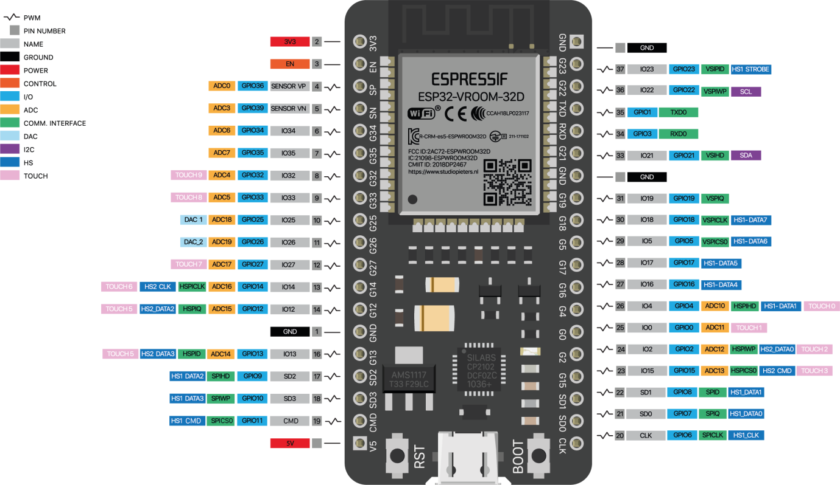

**Fig 3.1** : Pin Diagram of ESP32 Microcontroller

**Table 3.1 – Pin Configuration**

|  |  |  |
| --- | --- | --- |
| Pin Category | Pin Name | Details |
| Power | Micro-USB, 3.3V, 5V, GN | Micro-USB: ESP32 can be powered through USB port  5V: Regulated 5V can be supplied to this pin which is we be again regulated to 3.3V by on board regulator, to power the board.  3.3V: Regulated 3.3V can be supplied to this pin to power the board.  GND: Ground pins. |
| Enable | En | The pin and the button resets the microcontroller. |
| Analog Pins | ADC1_0 to ADC1_5 and ADC2_0 to ADC2_9 | Used to measure analog voltage in the range of 0-3.3V.  12-bit 18 Channel ADC |
| DAC pins | DAC1 and DAC2 | Used for Digital to analog Conversion |
| Input/Output Pins | GPIO0 to GPIO39 | Totally 39 GPIO pins, can be used as input or output pins. 0V (low) and 3.3V (high). But pins 34 to 39 can be used as input only |
| Capacitive Touch pins | T0 to T9 | These 10 pins can be used a touch pins normally used for capacitive pads |
| RTC GPIO pins | RTCIO0 to RTCIO17 | These 18 GPIO pins can be used to wake up the ESP32 from deep sleep mode. |
| Serial | Rx, Tx | Used to receive and transmit TTL serial data. |
| External Interrupts | All GPIO | Any GPIO can be use to trigger an interrupt. |
| PWM | All GPIO | 16 independent channel is available for PWM any GPIO can be made to work as PWM though software |
| VSPI | GPIO23 (MOSI), GPIO19(MISO), GPIO18(CLK) and GPIO5 (CS) | Used for SPI-1 communication. |
| HSPI | GPIO13 (MOSI), GPIO12(MISO), GPIO14(CLK) and GPIO15 (CS) | Used for SPI-2 communication. |
| IIC | GPIO21(SDA), GPIO22(SCL) | Used for I2C communication. |
| AREF | AREF | To provide reference voltage for input voltage. |

**Table 3.2 - ESP32 Technical Specifications**

|  |  |
| --- | --- |
| Microprocessor | Tensilica Xtensa LX6 |
| Maximum Operating Frequency | 240MHz |
| Operating Voltage | 3.3V |
| Analog Input Pins | 12-bit, 18 Channel |
| DAC Pins | 8-bit, 2 Channel |
| Digital I/O Pins | 39 (of which 34 is normal GPIO pin) |
| DC Current on I/O Pins | 40 mA |
| DC Current on 3.3V Pin | 50 mA |
| SRAM | 520 KB |
| Communication | SPI(4), I2C(2), I2S(2), CAN, UART(3) |
| Wi-Fi | 802.11 b/g/n |
| Bluetooth | V4.2 – Supports BLE and Classic Bluetooth |

**3.2.2 Load Cell**

A load cell is a force [transducer](https://en.wikipedia.org/wiki/Transducer). It converts a [force](https://en.wikipedia.org/wiki/Force) such as tension, compression, pressure, or torque into an electrical signal that can be measured and standardized. As the force applied to the load cell increases, the electrical signal changes proportionally. The most common types of load cell used are strain gauges, pneumatic, and hydraulic.

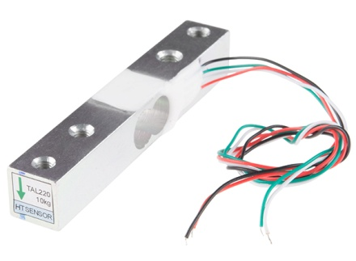

**Fig 3.2 –** Load Cell

**3.2.3 MQ2 Gas Sensor**

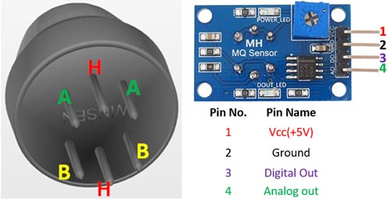

**Fig 3.3 :** Mq2 Gas Sensor

**Table 3.3 - Pin Configuration**

|  |  |  |
| --- | --- | --- |
| Pin No: | Pin Name: | Description |
| For Module | | |
| 1 | Vcc | This pin powers the module, typically the operating voltage is +5V |
| 2 | Ground | Used to connect the module to system ground |
| 3 | Digital Out | You can also use this sensor to get digital output from this pin, by setting a threshold value using the potentiometer |
| 4 | Analog Out | This pin outputs 0-5V analog voltage based on the intensity of the gas |
| For Sensor | | |
| 1 | H -Pins | Out of the two H pins, one pin is connected to supply and the other to ground |
| 2 | A-Pins | The A pins and B pins are interchangeable. These pins will be tied to the Supply voltage. |
| 3 | B-Pins | The A pins and B pins are interchangeable.   One pin will act as output while the other will be pulled to ground. |

**Features:**

* Operating Voltage is +5V
* Can be used to Measure or detect LPG, Alcohol, Propane, Hydrogen, CO and even methane
* Analog output voltage: 0V to 5V
* Digital Output Voltage: 0V or 5V (TTL Logic)
* Preheat duration 20 seconds
* Can be used as a Digital or analog sensor
* The Sensitivity of Digital pin can be varied using the potentiometer

**3.2.4 LM35 Temperature Sensor**

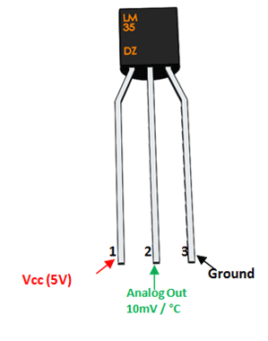

**Fig 3.4** - LM-35 Pinout diagram

**Table 3.4 : Pin Configuration**

|  |  |  |
| --- | --- | --- |
| Pin Number | Pin Name | Description |
| 1 | Vcc | Input voltage is +5V for typical applications |
| 2 | Analog Out | There will be increase in 10mV for raise of every 1°C. Can range from -1V(-55°C) to 6V(150°C) |
| 3 | Ground | Connected to ground of circuit |

**LM35 Regulator Features:**

* Minimum and Maximum Input Voltage is 35V and -2V respectively. Typically 5V.
* Can measure temperature ranging from -55°C to 150°C
* Output voltage is directly proportional (Linear) to temperature (i.e.) there will be a rise of 10mV (0.01V) for every 1°C rise in temperature.
* ±0.5°C  Accuracy
* Drain current is less than 60uA
* Low cost temperature sensor
* Small and hence suitable for remote applications
* Available in TO-92, TO-220, TO-CAN and SOIC package

**3.2.5 Buzzer**

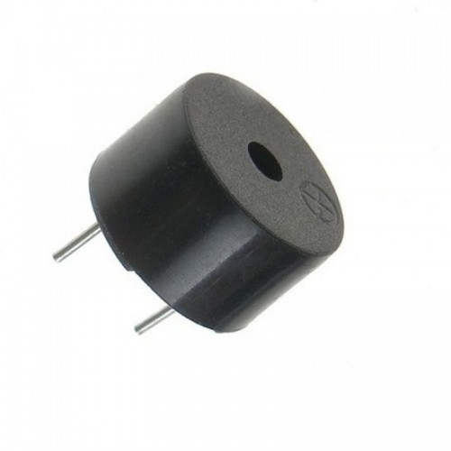

**Fig 3.5 –** Buzzer

It's simple, tone(buzzer, 1000) sends a 1KHz sound signal to pin 9, delay(1000) pause the program for one second and noTone(buzzer) stops the signal sound. The loop() routine will make this run again and again making a short beeping sound. Download the code from here and open it with Arduino IDE.

**3.2.6 HX711 ADC IC**

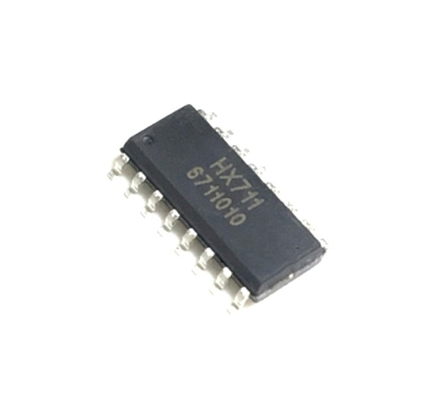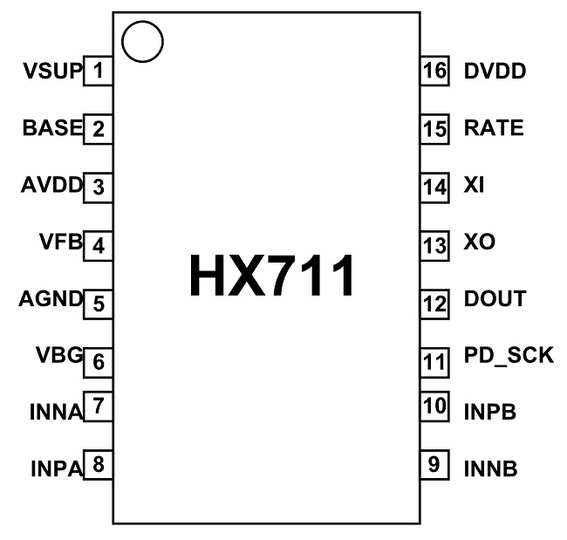

**Fig3.6** – HX711 IC Pinout

**Table 3.5 -** HX711 Pin Configuration

|  |  |  |  |
| --- | --- | --- | --- |
| Pin No. | Pin Name | Function | Description |
| 1 | VSUP | Power | Regulator supply: 2.7to 5.5V |
| 2 | BASE | Analog Output | Regulator control output (NC when not used） |
| 3 | AVDD | Power | Analog supply: 2.6 to 5.5V |
| 4 | VFB | Analog Input | Regulator control input (connect to AGND when not used） |
| 5 | AGND | Ground | Analog Ground |
| 6 | VBG | Analog Output | Reference bypass output |
| 7 | INA- | Analog Input | Channel A negative input |
| 8 | INA+ | Analog Input | Channel A positive input |
| 9 | INB- | Analog Input | Channel B negative input |
| 10 | INB+ | Analog Input | Channel B positive input |
| 11 | PD_SCK | Digital Input | Power down control (high active) and serial clock input |
| 12 | DOUT | Digital Output | Serial data output |
| 13 | XO | Digital I/O | Crystal I/O (NC when not used） |
| 14 | XI | Digital Input | Crystal I/O or external clock input, PIN is LOW: use on-chip oscillator |
| 15 | RATE | Digital Input | Output data rate control, PIN is LOW: 10Hz; PIN is HIGH: 80Hz |
| 16 | DVDD | Power | Digital supply: 2.6 to 5.5V |

HX711 is an ADC chip with preamplifier included. The chip is specifically designed for weight scales applications. The load cells which usually measure weight provide voltage outputs in millivolts. These outputs are difficult to handle directly by controllers, so we can use HX711 IC which takes these voltage signals and provide standard digital values which can be used by a microcontroller. The chip has integrated preamplifier specifically to handle these low voltages.

HX711 is a16 pin device.The chip is available in various packages choose one based on your requirement. The description for each pin is given below.

**HX711 Features and Specifications**

* Two selectable differential input channels
* On-chip active low noise PGA with selectable gain of 32, 64 and 128
* On-chip power supply regulator for load-cell andADC analog power supply
* On-chip oscillator requiring no externalcomponent with optional external crystal
* On-chip power-on-reset
* Simple digital control and serial interface: pin-driven controls, no programming needed
* Selectable 10SPS or 80SPS output data rate
* Simultaneous 50 and 60Hz supply rejection
* Current consumption:normal operation < 1.5mA, power down < 1uA
* Operation supply voltage range: 2.6V to 5.5V
* Operation temperature range: -40℃ to +85℃

**3.2.7 LCD Display**

Liquid -crystal display known as LCD is a flat-panel display or electronically modulated optical device that uses the light modulating properties of liquid crystals, liquid crystals do not emit light directly, instead using a backlight or reflector to produce images in color or monochrome. LCDs are available to display arbitrary or fixed images with low information content, which can be displayed or hidden, such as preset words, digits and 7 -segment displays, as in a digital clock. They use the same basic technology, except that arbitrary images and made up of a large number of small pixels. LCDs are used in wide range of applications such as: computer monitors, televisions, aircraft cockpit displays indoor etc.

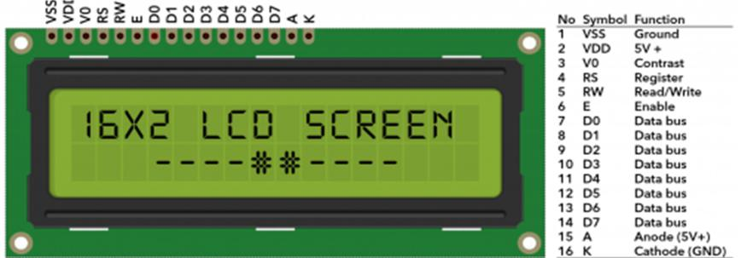

**Fig-3.7**  LCD Display

**Table 3.6** LCD Pin Description

|  |  |  |
| --- | --- | --- |
| Pin No: | Pin Name: | Description |
| 1 | Vss (Ground) | Ground pin connected to system ground |
| 2 | Vdd (+5 Volt) | Powers the LCD with +5V (4.7V – 5.3V) |
| 3 | VE (Contrast V) | Decides the contrast level of display. Grounded to get maximum contrast. |
| 4 | Register Select | Connected to Microcontroller to shift between command/data register |
| 5 | Read/Write | Used to read or write data. Normally grounded to write data to LCD |
| 6 | Enable | Connected to Microcontroller Pin and toggled between 1 and 0 for data acknowledgement |
| 7 | Data Pin 0 | Data pins 0 to 7 forms a 8-bit data line. They can be connected to Microcontroller to send 8-bit data.  These LCD’s can also operate on 4-bit mode in such case Data pin 4,5,6 and 7 will be left free. |
| 8 - 14 | Data Pin 1 | Data Pin |
| 15 | LED Positive | Backlight LED pin positive terminal |
| 16 | LED Negative | Backlight LED pin negative terminal |

**3.2.8 I2C Module**

I2C is a serial protocol for two-wire interface to connect low-speed devices like microcontrollers, I/O interfaces and other similar peripherals in embedded systems. I2C uses only two wires: SCL (serial clock) and SDA (serial data). Both need to be pulled up with a resistor to +Vdd . There are also I2C level shifters which can be used to connect to two I2C buses with different voltages.

I2C bus is used by many integrated circuits and is simple to implement. Any microcontroller can communicate with I2C devices even if it has no special I2C interface. I2C bus can also use high speed modes to transfer large amounts of data.

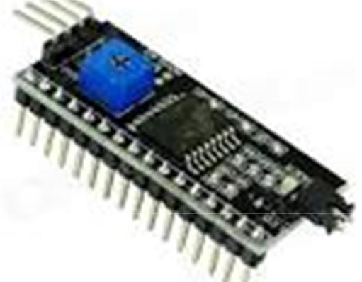

**Fig-3.8 -** I2C Module

**3.3 Software Components**

The Arduino IDE software is known that Arduino IDE is open source software. This software is used to compile the program into the microcontroller. It uses C-programming language for coding. There is two parts in this code mainly, one is Void setup () which is known as preparation for the program and it runs only once and another one is void loop () which is known as execution for the program. In this software we have used some function from the Arduino library to get the authentication of SIM, GPS data. We used AT command for SIM900A kit to connect with the Arduino for sending message . We have also used some other libraries HX711.h, WiFi.h, LiquidCrystal_I2C.h, ESP32_MailClient.h

**CHAPTER 4**

**PROTOTYPE MECHANISM**

**4.1 Introduction**

As everyone in this competitive world prefers to make the things easy and simple to handle, this project sets an example to some extent. An embedded system can be defined as a computing device that does a specific focused job. Appliances such as the air-conditioner, VCD player, DVD player, printer, fax machine, mobile phone etc. are examples of embedded systems. Each of these appliances will have a processor and special hardware to meet the specific requirement of the application along with the embedded software that is executed by the processor for meeting that specific requirement. The embedded software is also called “firmware”. The embedded system market is one of the highest growth areas as these systems are used in very market segment consumer electronics, office automation, industrial utomation, biomedical engineering, wireless communication, data communication, telecommunications, transportation, military and so on.

**4.2 Prototype**

The objective of the proposed system is to continuously measure the weight of the cylinder and as soon as it reaches the minimum threshold it will automatically sends an SMS alert to the user as well as Authorized LPG agent so that they can act accordingly. This system also designed to detect LPG gases such as propane and butane. The allowed level for butane is 900ppm above which it is considered to be of high level and poses a danger. The threshold level of weight of the cylinder is used for automatic cylinder booking.

**Fig 4.1 Flow Chart**

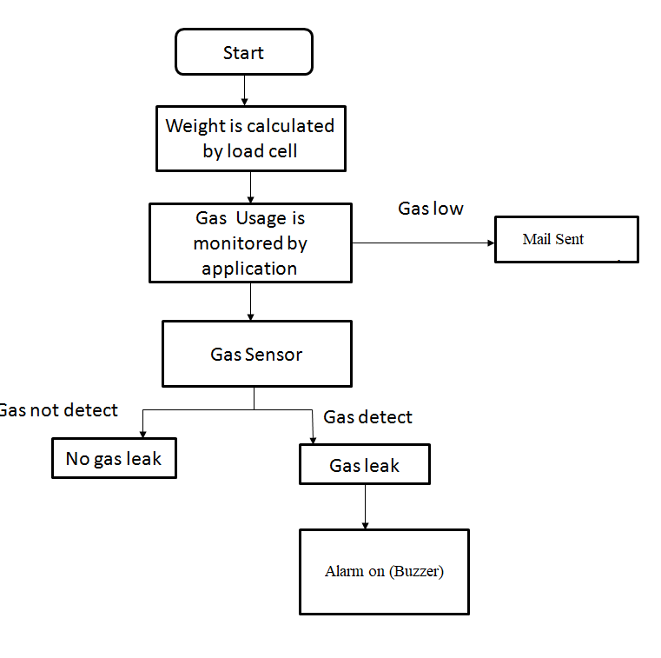

**4.2.1 Design and Working principle**

Our model is made up with 3 major components: ESP32 microcontroller, LoadCell and HX711IC. The core part of this system is the microcontroller. The coding of this system has been done using Arduino IDE programming language. The LCD display will display the gas level and temperature near the cylinder and weight of the cylinder.

When the LPG gas cylinder crosses the minimum threshold weight the microcontroller activates the smpt server and sends the mail to the receiver which is the owner’s mail stating that Low Gas Detected Book your LPG Immediately. The Microcontroller simultaneously monitors the temperature and gas via temperature sensor and gas sensor. Whenever any gas occurs near the cylinder or any high temperature detected near the cylinder the Buzzer rings and gives the alert to the owner.

**CHAPTER 5**

**RESULTS AND DISCUSSIONS**

**5.1 Process**

The system prototype is constructed and when a Small amount of LPG is brought near the system, the system sensor detects the leakage and activates the alarm. Also system prototype continuously monitors the weight of the LPG cylinder and send the alert for booking the cylinder.

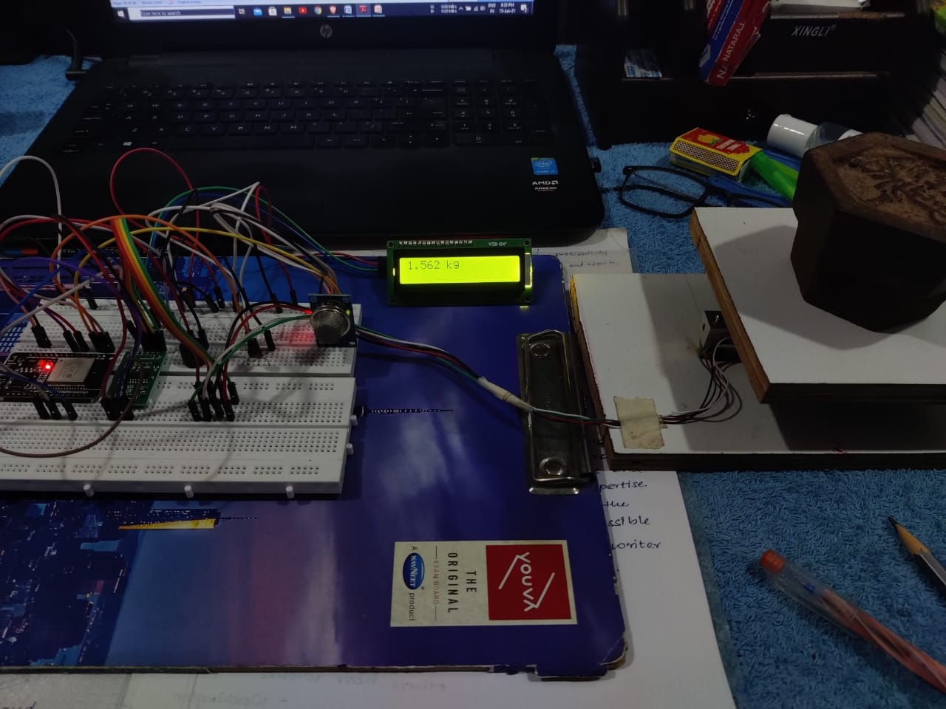

**Fig 5.1 – Placing 1500 grams on LoadCell**

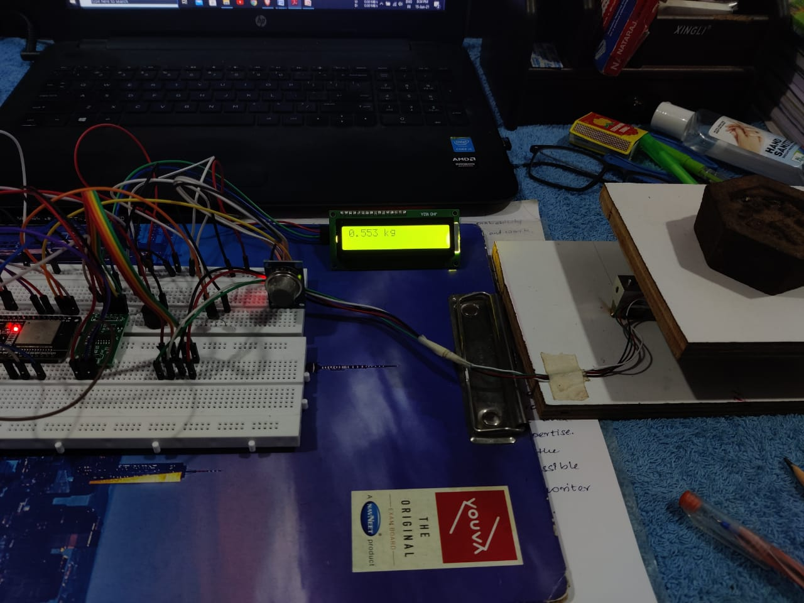

**Fig 5.2 – Removing 1 Kg from LoadCell (Present 500 grams)**

As our minimum threshold weight is 900 grams and at present there is 500 grams on LoadCell which is less than 900 grams smpt server sends mail to the receiver’s mail.

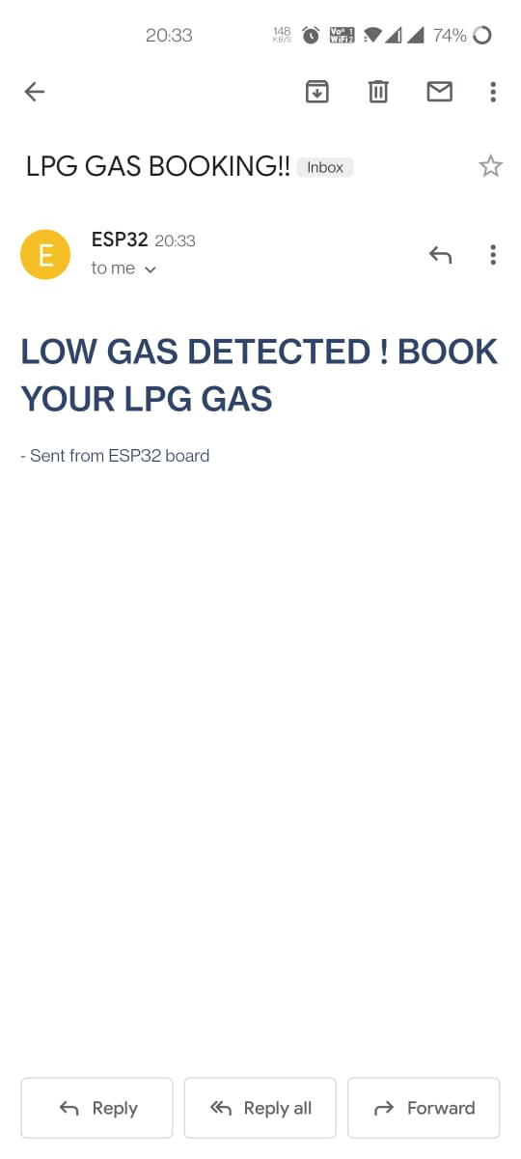

**Fig 5.3 – Mail Sent**

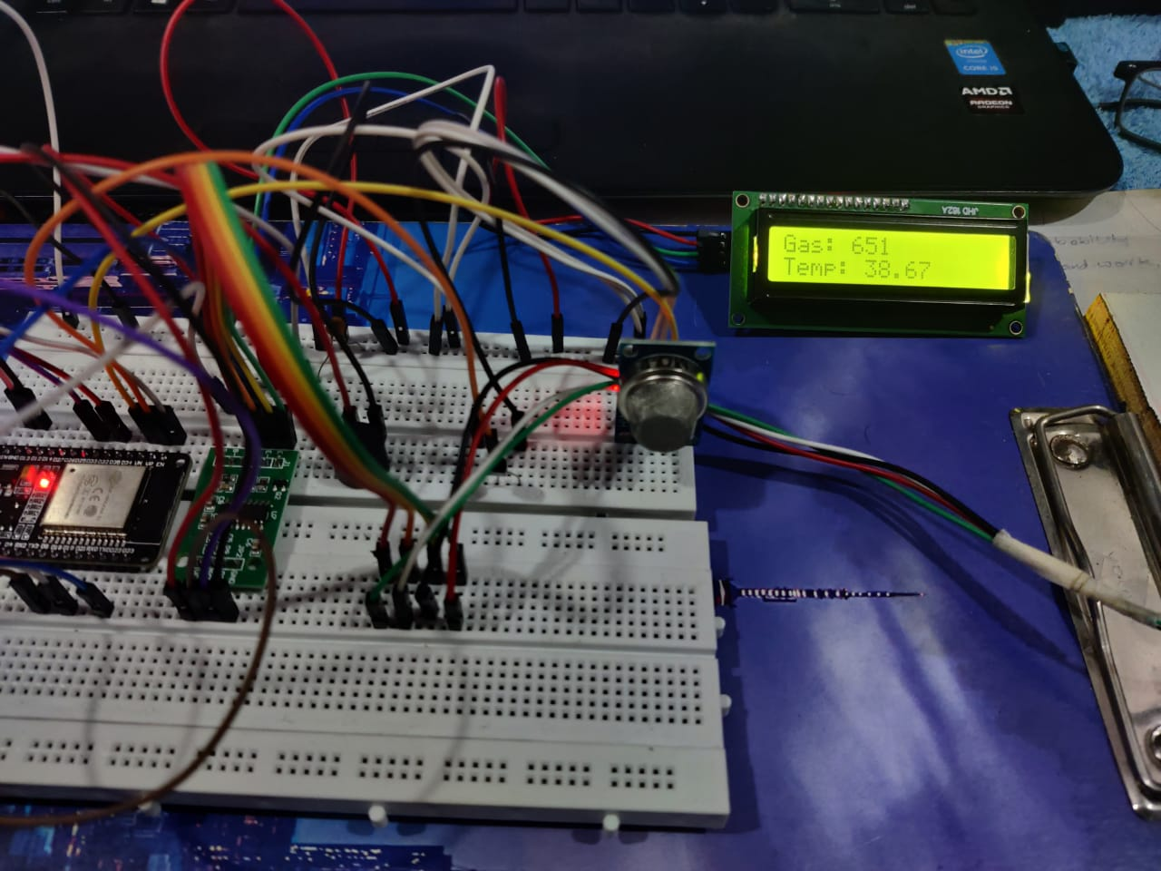

**Fig 5.4 – Temperature and gas on LCD Display**

**CHAPTER 6**

**CONCLUSION AND FUTURE SCOPE**

**6.1 Conclusion**

As we shorted out the problems faced by LPG gas consumers so we come up with some solutions to meet the few requirements of them, as we made our system is completely automate the process of refill booking. Our system is also reasoned to help customers to upgrade their safety norms, act in accordingly with minimum requirements on environmental issues and mostly the basic function being prevented by major disasters and protect life and property from reputed Accidents. The primary objective of our project is to measure the gas present in the cylinder when weight of the cylinder is below the fixed load, this can be done using the weight sensors. The gas retailer gets the order for a new cylinder and the house owner (consumer) receives the message regarding the status and the secondary objective is to provide any malfunction in gas servicing system in order to prevent damage or explosion of LPG. Thus the system developed by us will somehow help the LPG Gas Consumers to lead a comfortable life.

**6.2 Future Scope**

This monitoring system can be further enhanced by using GSM to send the alert messages to user, which supports the another real-time application. For industrial purposes mobile robot can be developed for detecting multiple gas concentrations. Addition of load cell can also be used as pressure sensor which detects the amount of gas in the cylinder and also detects high pressure gas in cylinder pipe, displaying the alert messages via SMS and LCD displays.

**References**

1. “Smart Gas Cylinder Using Embedded System”, Issn (Online) 2321 – 2004 Issn (Print) 2321 – 5526, International Journal Of Innovative Research In Electrical, Electronics, Instrumentation And Control Engineering Vol. 2, Issue 2, February 2014.
2. “Design and Implementation of an Economic Gas Leakage Detector” A. MAHALINGAM, R. T. NAAYAGI,1, N. E. MASTORAKIS§ Department of Engineering Systems school of Engineering, University of Greenwich (Medway Campus)Chatham Maritime, Kent ME4 4TBUNITED KINGDOM, article in Recent Researches in Applications of Electrical and Computer Engineering.
3. “Microcontroller Based LPG Gas Leakage Alert System”, Manas Halder, Sumanta Chatterjee.
4. LPG Gas Leakage Detection and Alert System E. Jebamalar Leavline1 , D. Asir Antony Gnana Singh2 , B. Abinaya3 H. Deepika4 Department of Electronics and Communication Engineering1 , Department of Computer Science and Engineering, Anna University, BIT Campus, Tiruchirappalli.
5. https://www.elprocus.com/simple-steps-burn-program-into-microcontroller/
6. <https://www.espressif.com/en/products/socs/esp32>
7. https://components101.com/microcontrollers/esp32-devkitc

**Appendices –**

**Source Code-**

#include <Arduino.h>

#include "WiFi.h"

#include <LiquidCrystal_I2C.h>

#define WIFI_NETWORK " *wifi username* "

#define WIFI_PASSWORD " *wifi password* "

#define WIFI_TIMEOUT_MS 20000

#include "HX711.h"

#define DOUT 25

#define CLK 18

#include "ESP32_MailClient.h"

HX711 scale(DOUT, CLK);

LiquidCrystal_I2C lcd(0x27, 16, 2);

float calibration_factor = -100250;

#define emailSenderAccount " *Sender email* "

#define emailSenderPassword " *Sender Password* "

#define emailRecipient “ *receiver mail* "

#define smtpServer "smtp.gmail.com"

#define smtpServerPort 465

#define emailSubject "LPG GAS BOOKING!!"

SMTPData smtpData; // The Email Sending data object contains config and data to send

void sendCallback(SendStatus info); // Callback function to get the Email sending status

void connectToWiFi(){

Serial.print("Connecting to WiFi");

WiFi.mode(WIFI_STA);

WiFi.begin(WIFI_NETWORK,WIFI_PASSWORD);

unsigned long startAttemptTime = millis();

while(WiFi.status()!=WL_CONNECTED && millis()-startAttemptTime < WIFI_TIMEOUT_MS)

{

Serial.print(".");

delay(100);

}

if(WiFi.status()!=WL_CONNECTED)

{

Serial.print(".");

}

else

{

Serial.print("Connected");

Serial.println(WiFi.localIP());

}

}

const int a = A0;

int R= 0;

double t = 0;

int Buzzer = 32; // used for ESP32

int Gas_analog = 39; // used for ESP32

int abc=0;

void setup() {

Serial.begin(115200);

connectToWiFi();

lcd.begin();

lcd.clear();

lcd.print("Welcome");

delay(2000);

pinMode(Buzzer, OUTPUT);

Serial.println("HX711 Calibration");

Serial.println("Remove all weight from scale");

Serial.println("After readings begin, place known weight on scale");

Serial.println("Press a,s,d,f to increase calibration factor by 10,100,1000,10000 respectively");

Serial.println("Press z,x,c,v to decrease calibration factor by 10,100,1000,10000 respectively");

Serial.println("Press t for tare");

scale.set_scale();

scale.tare(); //Reset the scale to 0

long zero_factor = scale.read_average(); //Get a baseline reading

Serial.print("Zero factor: "); //This can be used to remove the need to tare the scale. Useful in permanent scale projects.

Serial.println(zero_factor);

}

void loop() {

int gassensorAnalog = analogRead(Gas_analog);

R = analogRead(a);

t = R / 9.31;

Serial.print(" Temperature in C = ");

Serial.print(t,1);

lcd.clear();

lcd.setCursor(0,1);

lcd.print("Temp: ");

lcd.setCursor(6,1);

lcd.print(t);

Serial.print("\t Gas Sensor(Analog): ");

Serial.println(gassensorAnalog);

lcd.setCursor(0,0);

lcd.print("Gas: ");

lcd.setCursor(5,0);

lcd.print(gassensorAnalog);

delay(1000);

if(t>50 || gassensorAnalog >1000)

{

lcd.clear();

}

if(t>50)

{

Serial.println("High Temperature");

lcd.setCursor(0,1);

lcd.print("High Temp");

digitalWrite(Buzzer,HIGH);

delay(1000);

digitalWrite(Buzzer,LOW);

}

if (gassensorAnalog > 1000) {

Serial.println("!WARNING! GAS DETECTED");

lcd.setCursor(0,0);

lcd.print("GAS DETECTED");

digitalWrite (Buzzer, HIGH) ; // High Buzzer

delay(1000);

digitalWrite (Buzzer, LOW) ; // No Buzzer

}

delay(100);

scale.set_scale(calibration_factor); //Adjust the readings to the calibration factor

Serial.print("Reading: ");

Serial.print(scale.get_units(), 3);

Serial.print(" kg");

lcd.clear();

lcd.print(scale.get_units() ,3);

lcd.print(" kg");

Serial.print(" \t calibration_factor: ");

Serial.print(calibration_factor);

Serial.println();

if(scale.get_units()<0.9 && abc==1)

{

smtpData.setLogin(smtpServer, smtpServerPort, emailSenderAccount, emailSenderPassword);

// For library version 1.2.0 and later which STARTTLS protocol was supported,the STARTTLS will be

// enabled automatically when port 587 was used, or enable it manually using setSTARTTLS function.

//smtpData.setSTARTTLS(true);

smtpData.setSender("ESP32", emailSenderAccount);

smtpData.setPriority("High");

smtpData.setSubject(emailSubject);

smtpData.setMessage("<div style=\"color:#2f4468;\"><h1>LOW GAS DETECTED ! BOOK YOUR LPG GAS</h1><p>- Sent from ESP32 board</p></div>", true);

smtpData.addRecipient(emailRecipient);

smtpData.setSendCallback(sendCallback);

if (!MailClient.sendMail(smtpData))

Serial.println("Error sending Email, " + MailClient.smtpErrorReason());

smtpData.empty();

abc=0;

}

if(scale.get_units()>0.9)

{

abc=1;

}

if(Serial.available())

{

char temp = Serial.read();

if(temp == '+' || temp == 'a')

calibration_factor += 10;

else if(temp == '-' || temp == 'z')

calibration_factor -= 10;

else if(temp == 's')

calibration_factor += 100;

else if(temp == 'x')

calibration_factor -= 100;

else if(temp == 'd')

calibration_factor += 1000;

else if(temp == 'c')

calibration_factor -= 1000;

else if(temp == 'f')

calibration_factor += 10000;

else if(temp == 'v')

calibration_factor -= 10000;

else if(temp == 't')

scale.tare(); //Reset the scale to zero

}

delay(2000);

Serial.println("___________________________________");

}

void sendCallback(SendStatus msg) {

Serial.println(msg.info());

}